**Daily Scrum or Standup Meeting**

Team name: Alpha Squad

Scrum Master: Isaak Johnson

Date: Nov 20

|  |  |  |  |
| --- | --- | --- | --- |
| **Team Member** | **What did you do since the last scrum?** | **What do you plan to do before the next scrum?** | **What obstacles do you have?** |
| Alex Beeston | added Django messages for invalid auction users | write unit test for editing a winning bid on live item | none |
| Joey Carlisle | Nothing | Testing | nothing, sorry team |
| Isaak Johnson | Worked on unit tests and making the initdb function represent a testable silent auction | Finishing the unit tests fully | Time |
| Ben Taylor | Nothing | Finish the payment amounts at the top of the necessary pages. | none |

# Burndown

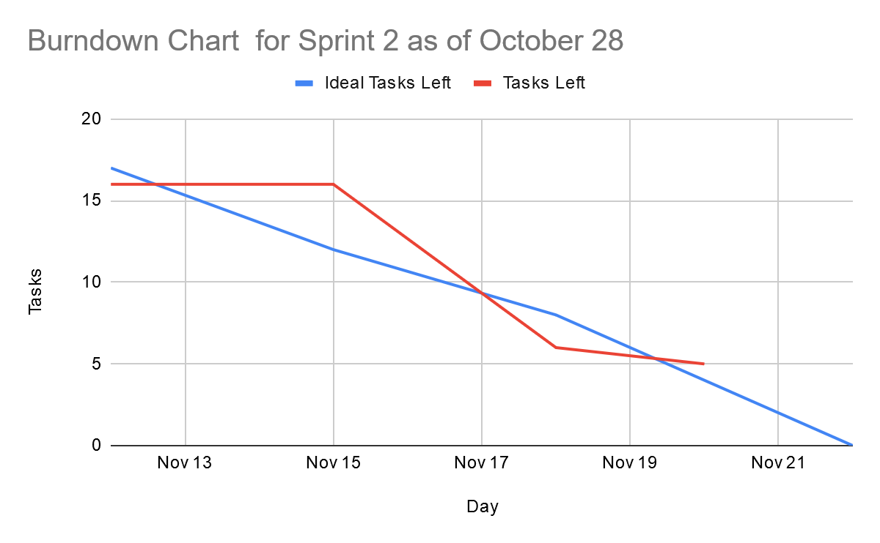

# Screenshot of you project board

